Project Design Phase-II
Data Flow Diagram & User Stories

Date | 5 july 2026
Project Name | Book Store
Maximum Marks | 4 Marks

Data Flow Diagrams:
A Data Flow Diagram (DFD) is a traditional visual representation of the information flows within a system. A neat and clear DFD can depict the right amount of the system requirement graphically. It shows how data enters and leaves the system, what changes the information, and where data is stored.
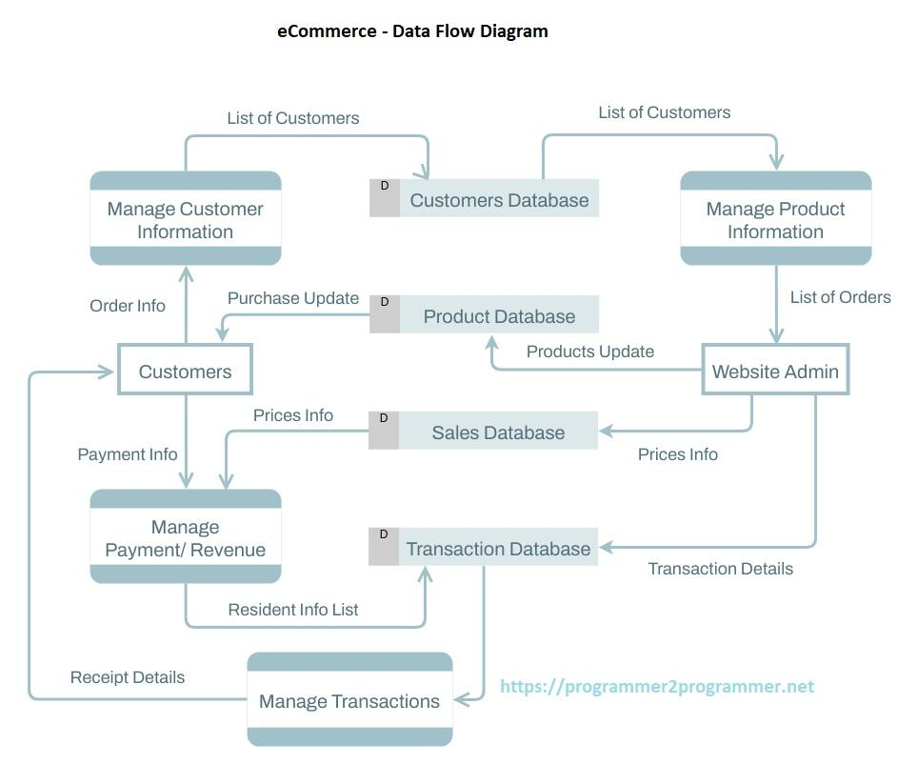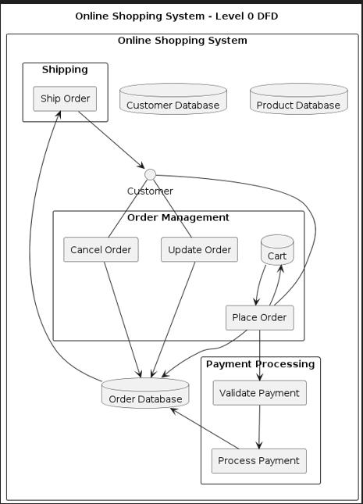

User Stories
User Type | Functional Requirement (Epic) | User Story Number | User Story / Task | Acceptance Criteria | Priority | Release
Customer (Web User) | Registration | USN-1 | As a user, I can register by entering my name, email, and password. | User account is created successfully. | High | Sprint-1
Customer (Web User) | Registration | USN-2 | As a user, I can receive a registration success message after signup. | Success notification is displayed. | High | Sprint-1
Customer (Web User) | Login | USN-3 | As a user, I can login using my email and password. | User can access dashboard/home page. | High | Sprint-1
Customer (Web User) | Login | USN-4 | As a user, I can logout from the application. | Session is terminated successfully. | High | Sprint-1
Customer (Web User) | Book Browsing | USN-5 | As a user, I can view all available books. | List of books is displayed. | High | Sprint-1
Customer (Web User) | Search & Filter | USN-6 | As a user, I can search books by title. | Relevant books are displayed. | High | Sprint-2
Customer (Web User) | Search & Filter | USN-7 | As a user, I can filter books by genre, author, price, and rating. | Filtered books are displayed correctly. | High | Sprint-2
Customer (Web User) | Book Details | USN-8 | As a user, I can view detailed information about a book. | Book description, price, rating, and reviews are shown. | High | Sprint-2
Customer (Web User) | Cart Management | USN-9 | As a user, I can add books to my cart. | Selected book appears in cart. | High | Sprint-2
Customer (Web User) | Cart Management | USN-10 | As a user, I can remove books from my cart. | Book is removed successfully. | Medium | Sprint-2
Customer (Web User) | Cart Management | USN-11 | As a user, I can update the quantity of books in my cart. | Cart total updates correctly. | Medium | Sprint-2
Customer (Web User) | Order Management | USN-12 | As a user, I can place an order for books in my cart. | Order is successfully created. | High | Sprint-3
Customer (Web User) | Order Management | USN-13 | As a user, I can view my order history. | Previous orders are displayed. | High | Sprint-3
Customer (Web User) | Order Management | USN-14 | As a user, I can track the status of my orders. | Current order status is shown. | High | Sprint-3
Customer (Web User) | Reviews & Ratings | USN-15 | As a user, I can submit ratings and reviews for books. | Review is saved and displayed. | Medium | Sprint-3
Customer (Web User) | User Profile | USN-16 | As a user, I can view my profile information. | User details are displayed correctly. | Medium | Sprint-3
Customer (Web User) | User Profile | USN-17 | As a user, I can update my profile information. | Updated details are saved successfully. | Medium | Sprint-3
Administrator | Book Management | USN-18 | As an admin, I can add new books to the catalog. | New book is added successfully. | High | Sprint-2
Administrator | Book Management | USN-19 | As an admin, I can edit book information. | Updated details are reflected in catalog. | High | Sprint-2
Administrator | Book Management | USN-20 | As an admin, I can delete books from the catalog. | Selected book is removed. | High | Sprint-2
Administrator | Order Management | USN-21 | As an admin, I can view all customer orders. | Order list is displayed. | High | Sprint-3
Administrator | Order Management | USN-22 | As an admin, I can update order status. | Order status changes successfully. | High | Sprint-3
Administrator | User Management | USN-23 | As an admin, I can view registered users. | User list is displayed. | Medium | Sprint-3
Administrator | Dashboard | USN-24 | As an admin, I can view statistics such as users, books, and orders. | Dashboard analytics are displayed. | Medium | Sprint-3

